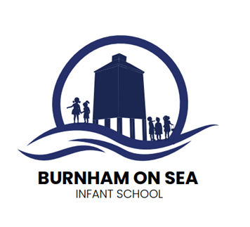

Burnham-on-Sea Infant School

'Nurturing Minds, Growing Potential, Enriching Futures'

***“The curriculum is everything you say and everything you do”***

**Professor Mick Waters**

**Curriculum Overview**

**Intent**

**At Burnham-on-Sea Community Infant School we believe our high standards are due to the rich and broad experiences the children have as they move through the school. Our curriculum is designed with our children’s needs in mind.**

**All teachers are responsible for providing an inclusive curriculum that is differentiated for those with Special Educational Needs or Disabilities (SEND). We have high expectations for all pupils and are committed to ensuring our curriculum complies with the Equality Act 2010 and the Special Educational Needs and Disability Regulations 2014.**

**Our inclusion statement emphasises the importance of providing an inclusive learning environment for all pupils including those with SEND. Additional information on this can be found on the SEND pages of our website.**

**Many of the children start school with relative weaknesses in spoken communication and understanding and vocabulary has become one of the key drivers in the planning and delivery of our curriculum. Learning throughout the curriculum centres around high quality texts and focused key vocabulary.**

**Our Values**

**We have 3 key values which underpin our curriculum.** **We aim to develop learners who are:**

Kind, Curious, Dedicated

**Details of how each of these skills are developed as the children progress through the school can be found on our Vision and Values page.**

**All children have access to a broad and balanced curriculum, incorporating all National Curriculum subjects including Religious Education and PSHE. We aspire for all pupils, including disadvantaged and those with special educational needs, to achieve as well as they can and meet their full potential. We are an inclusive school and place the needs of individuals at the heart of everything we do.**

**Implementation**

**Whilst designing a curriculum that will ensure our children leave us with secure basic skills in reading, writing and maths is of high importance, a breadth and depth of curriculum across a range of subjects and experiences is vital in order for them to develop a lifelong love of learning and to discover where their talents and interests may lie.**

**We build on children’s prior learning and provide first hand learning experiences in order to make learning meaningful, relevant, interesting and engaging.**

**We know that it is important that pupils develop their knowledge and skills in a progressive and sequential manner for all areas of the curriculum. Key knowledge and skills are revisited and built upon so that we ensure that pupils can make links with prior learning and that pupils know and remember more.  Detailed long term plans of our Early Years Foundation Stage and Key Stage 1, which outline what we teach, when, why and how can be found in each curriculum area, by clicking on the links below. Here you will find our subject overview statements and details of our sequential plans for learning for each subject. Our long term progression maps identify the knowledge, skills and vocabulary to be taught in each subject and set out in detail what is to be taught in detail to ensure consistency across classes.**

**Playtimes and time for social interaction between friends is valued in school.  As an Opal Play school we look to provide the children with a range of creative and exploratory play activities during their free play. As a school we have invested in equipment and training for staff so that all pupils can have a positive, rich and varied playtime.**

**Parental engagement is crucial to every child’s success and we strive to involve parents during their child’s learning journey.  For example, we hold workshops, invite parents to contribute to topics, hold a face-to-face parents’ evening every term and share learning success through our newsletters and website.**

**Impact**

**We are proud of the standards that the children achieve across all areas of the curriculum.**

**We consistently achieve good results in reading, writing and numeracy and our children leave the school at the end of Year 2 with a sense of belonging to a community where they have the confidence and skills to make decisions, self-evaluate, make connections and become lifelong learners.**

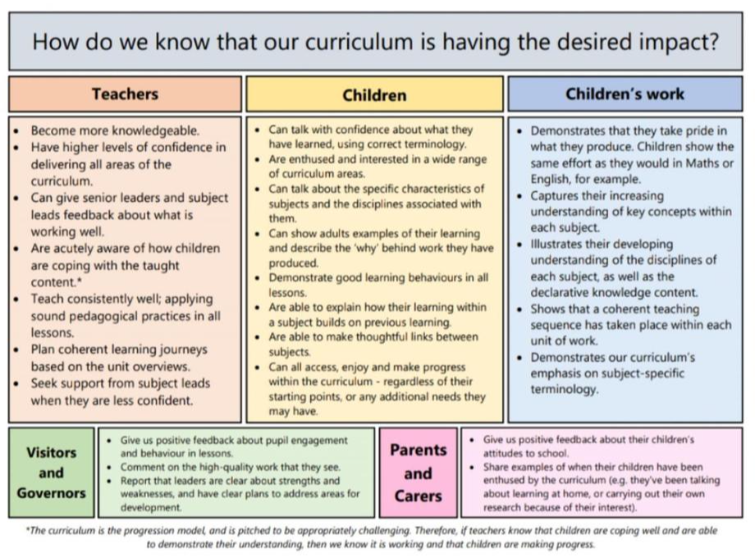

If you have any questions relating to the Curriculum, please contact the School Office on (01278) 782342 or via [office@burnhaminfants.com](mailto:office@burnhaminfants.com)