**Reading at Home**

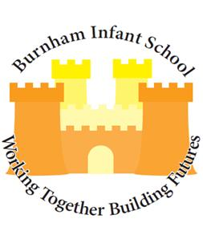

**Burnham-on-Sea Community Infant School**

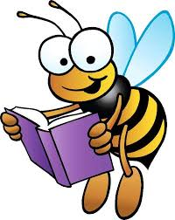

# Children learn to read by reading

Children are natural learners. They are constantly learning about their environment through interaction, exploration, trial and error, and ‘having a go’, at things.

Children watch what adults do and then act out what they have seen. This role-play of adult behaviour is an intrinsic component of childhood learning. As a child’s world experience expands, so deeper understandings are constructed.

New learning is always being built upon existing foundations, and existing structures are constantly being adapted to accommodate fresh insights.

From a very early age children can be encouraged to enjoy books by sharing them with adults. The six-month old child who turns the pages of a board book is beginning to behave like a reader.

The adult can build upon this by giving support and encouragement. By demonstrating how books work, talking about the illustrations and indicating how they relate to print, the adult is showing the child the meaning and purposes for reading.

# The literate environment

Children are surrounded by print from their earliest days at home, and in the wider community.

Teachers and parents can inspire this interest by taking children on a “print walk” around the neighbourhood; collecting examples of notices, signs, advertisements, and labels etc. including non-written symbols and in some areas printed in different language, scripts and visual texts.

 

We appreciate that parents have many commitments and not much time, but if we work together we can help children become confident readers.

# 

# Supporting the initial stages of reading development

**What can a parent do to help at home?**

→ Try to choose a quiet time with your child and make yourselves comfortable.

→ Let your child hold the book.

→ Point to the words as you read them.

→ Use the pictures as well; there is often an additional story in them.

→ Allow plenty of time for discussion before you turn over a page. A valuable question is: “what do you think will happen next?”

→ Let your child read the story to you afterwards, even if this is reciting by heart, or making the story up from the pictures. This is a very important stage in developing fluency.

→ Memorising is not cheating. Make reading fun!

→ Children learn to behave like readers by these activities. Praise all their attempts.

→ If your child is too tired or reluctant to join in, just make it an opportunity for you to read in a relaxed and enjoyable way. Do not force participation.

# More confident readers

It is still important to read with your child even when they have become a more confident reader.

Continue to support and guide your child.

Do not worry if your child’s reading is not word perfect. If they are making sense of the text, this does not matter, e.g. “house” instead of “home”, “Good dog Spot” instead of “Good boy Spot”.

It would matter, however, if they read “he got on his house and rode away” as this would have changed the meaning.

Always be ready to take over if your child is struggling. With your help, they will succeed and will want to read more and more as a result.

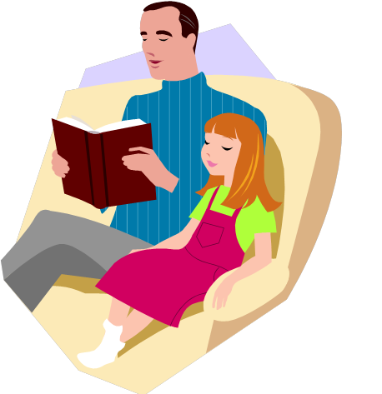

# What sort of things do I write in the reading record?

The following list is not an exhaustive list but offers suggestions that may be appropriate. It is very important to remember that the enjoyment factor is always worth commenting on.

Parents are not expected to comment on all of the following areas after each reading session!

→ How enthusiastic is the child about the choice of book?

→ Can the child remember the story so far?

→ Is the child reading using only the pictures for clues?

→ Does your child understand that the words they are reading mean something?

→ Can the child read words out of context, e.g. when you point to a word without reading the whole sentence?

→ Is the child confident to attempt new words?

→ What reading strategies is your child using, e.g. sounds, use of the picture, use of the context?

→ Can the child follow the text without using a finger or marker?

→ Is there a pattern to the mistakes your child is making, e.g. words ending in “ed” or starting in “sh”?

→ Does the child recognise mistakes and self-correct?

→ Is the child recognising many key words?

→ Is the child aware of punctuation?

→ Is the child reading with expression?

→ How long is the child able to sustain reading?

# Supporting the confident/free reader

Confident readers have reached the stage where they no longer wish to read to an adult and want to read silently to themselves. The interaction between the parent and child changes at this stage.

To ensure that the child’s reading development continues to move forward, we would encourage parents to question their child about what they are reading, at an appropriate time, to extend their reading and share their enjoyment of the book.

The following questions will provide ideas that you can extend to suit individual needs:

**Questions to ask when you child has chosen a book:**

→ What is the title of the book?

→ What kind of book is it? (fiction, non-fiction, poetry, short story etc.)

→ Who is the author / illustrator?

→ Have you read any other books by the same author?

→ What made you choose this book? (Author, cover, illustration, recommendation, etc.)

→ Did you read the blurb before selecting the book?

→ Could you tell anything about the book before you started reading it? What were the clues?

→ Have you read this book before? Why have you chosen it again?

# 

# Questions to ask before the child begins or resumes the book

→ What has happened so far?

→ What do you think will happen next?

→ What are the clues that make you think this?

→ How would you like the story to end?

→ Are you involved in the story? Why?

→ Where is the story set? Is there a description?

→ When is the story set? (Past, present, future)

→ Who are the characters in the story? Who do you like / dislike?

Why?

→ Do you feel similar to any of the characters? Tell me what is similar.

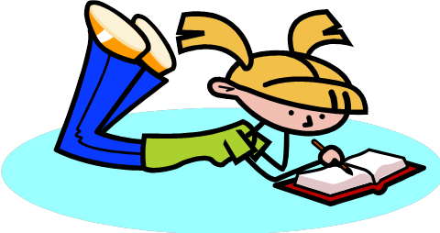

# Questions to ask when your child has finished reading the book

→ Was the book as you expected?

→ Was there anything you disliked about the story?

→ At what point did you decide you liked / disliked the story?

→ If you have read this book before, did you enjoy it more this time?

→ Did you notice anything special about the way language is used in this book? (Dialect, descriptive writing etc.)

→ If you had written this book, how would you have made it better?

→ Has anything that happens in this book ever happened to you?

→ Can you describe an exciting moment or favourite part of the story?

→ Is the story straightforward? Is there more than one story happening at the same time?

→ Who was telling the story? Was this the most important character in the story?

→ Do we get to know the characters quickly, or do they build up slowly through the book?

→ Was the ending as you expected? Did you like the way the story ended?

→ Do you like the illustrations? Do you have a favourite?

→ Would you recommend this book to your friends? Tell me what you would say to a friend.

**Reading must be enjoyed to gain maximum benefit:**

→ Avoid confrontation.

→ Offer alternative reading material e.g. internet access, magazines in which the children have an interest. Non-fiction often appeals to boys more than fiction.

→ Encourage reading at different times of the day or week.

→ Buy / borrow CDs from the library to encourage a love of language.

Listen to stories on journeys, at bedtime, etc.

→ Share reading activities and interact with the text together. For example, work together on the internet to book a holiday, explore a football team website, etc.

→ Share any problems with the teacher and ask for ideas.